**IE1204 Digital Design - Lab Report**

**Module 1**

Goal

Procedure

Showcase

**Module 2**

Goal

Procedure

Showcase

**Module 3**

Goal

Procedure

Showcase

**Module 4**

Goal

Procedure

Showcase

# Module 1

### Goal

To build an OR gate out of transistors, jumper wires, and a power source.

### Procedure

The goal was achieved by placing three P-MOS transistors in series connected to a transistor-made NOT gate, as well as three N-MOS transistors in parallel, connected to the same transistor-made NOT gate.

### Showcase

Diagram of Module:

# 

# 

# 

Logisim Simulation of Module:

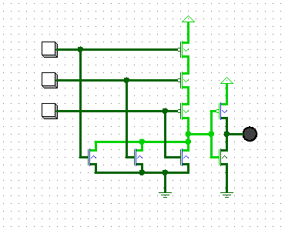

# 

# 

Actual Module:

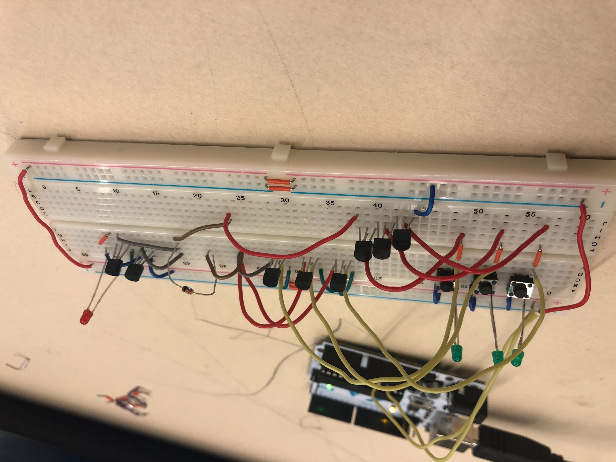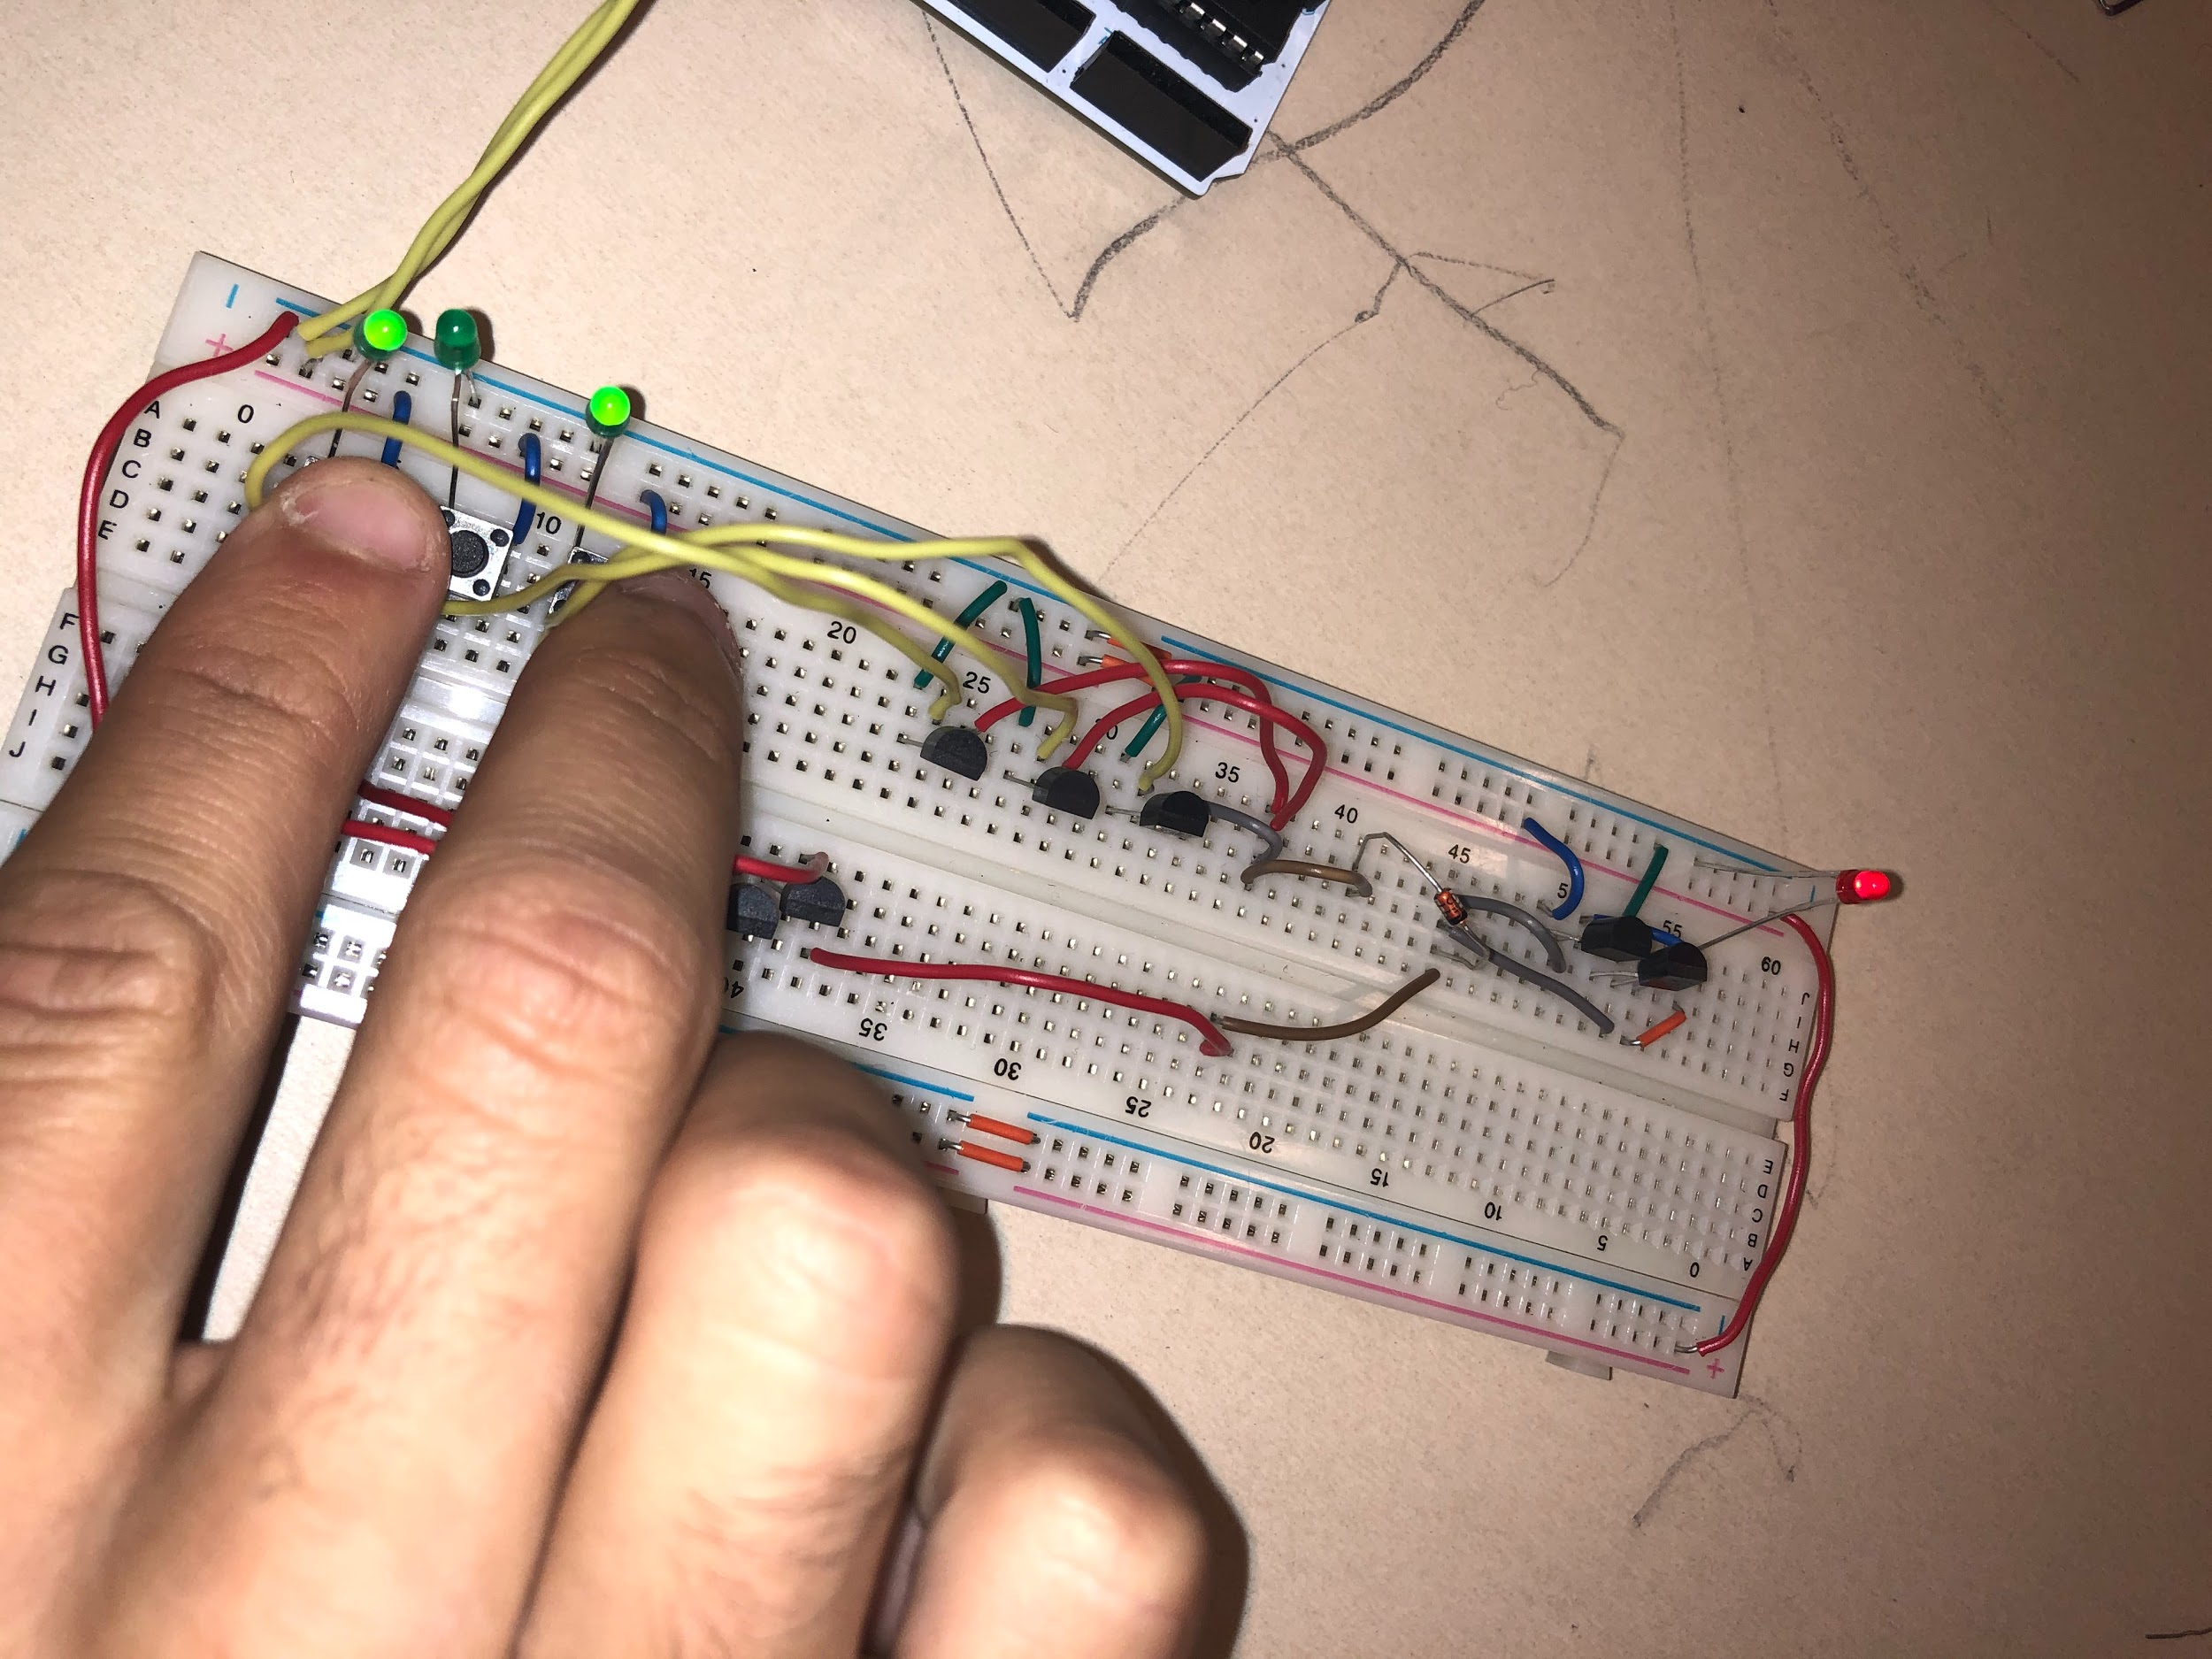

# Module 2

### Goal

The goal of this module was to design an arbitrary truth table based on the digits of my birthday, and to design a circuit for it.

### Procedure

By writing a truth table with the digits of my birthday as the outputs, I was able to put this truth table into a K-Map. From the K-Map, I was able to write a simplified boolean algebraic equation, which I then designed in my breadboard.

### Showcase

Diagram of the Module:

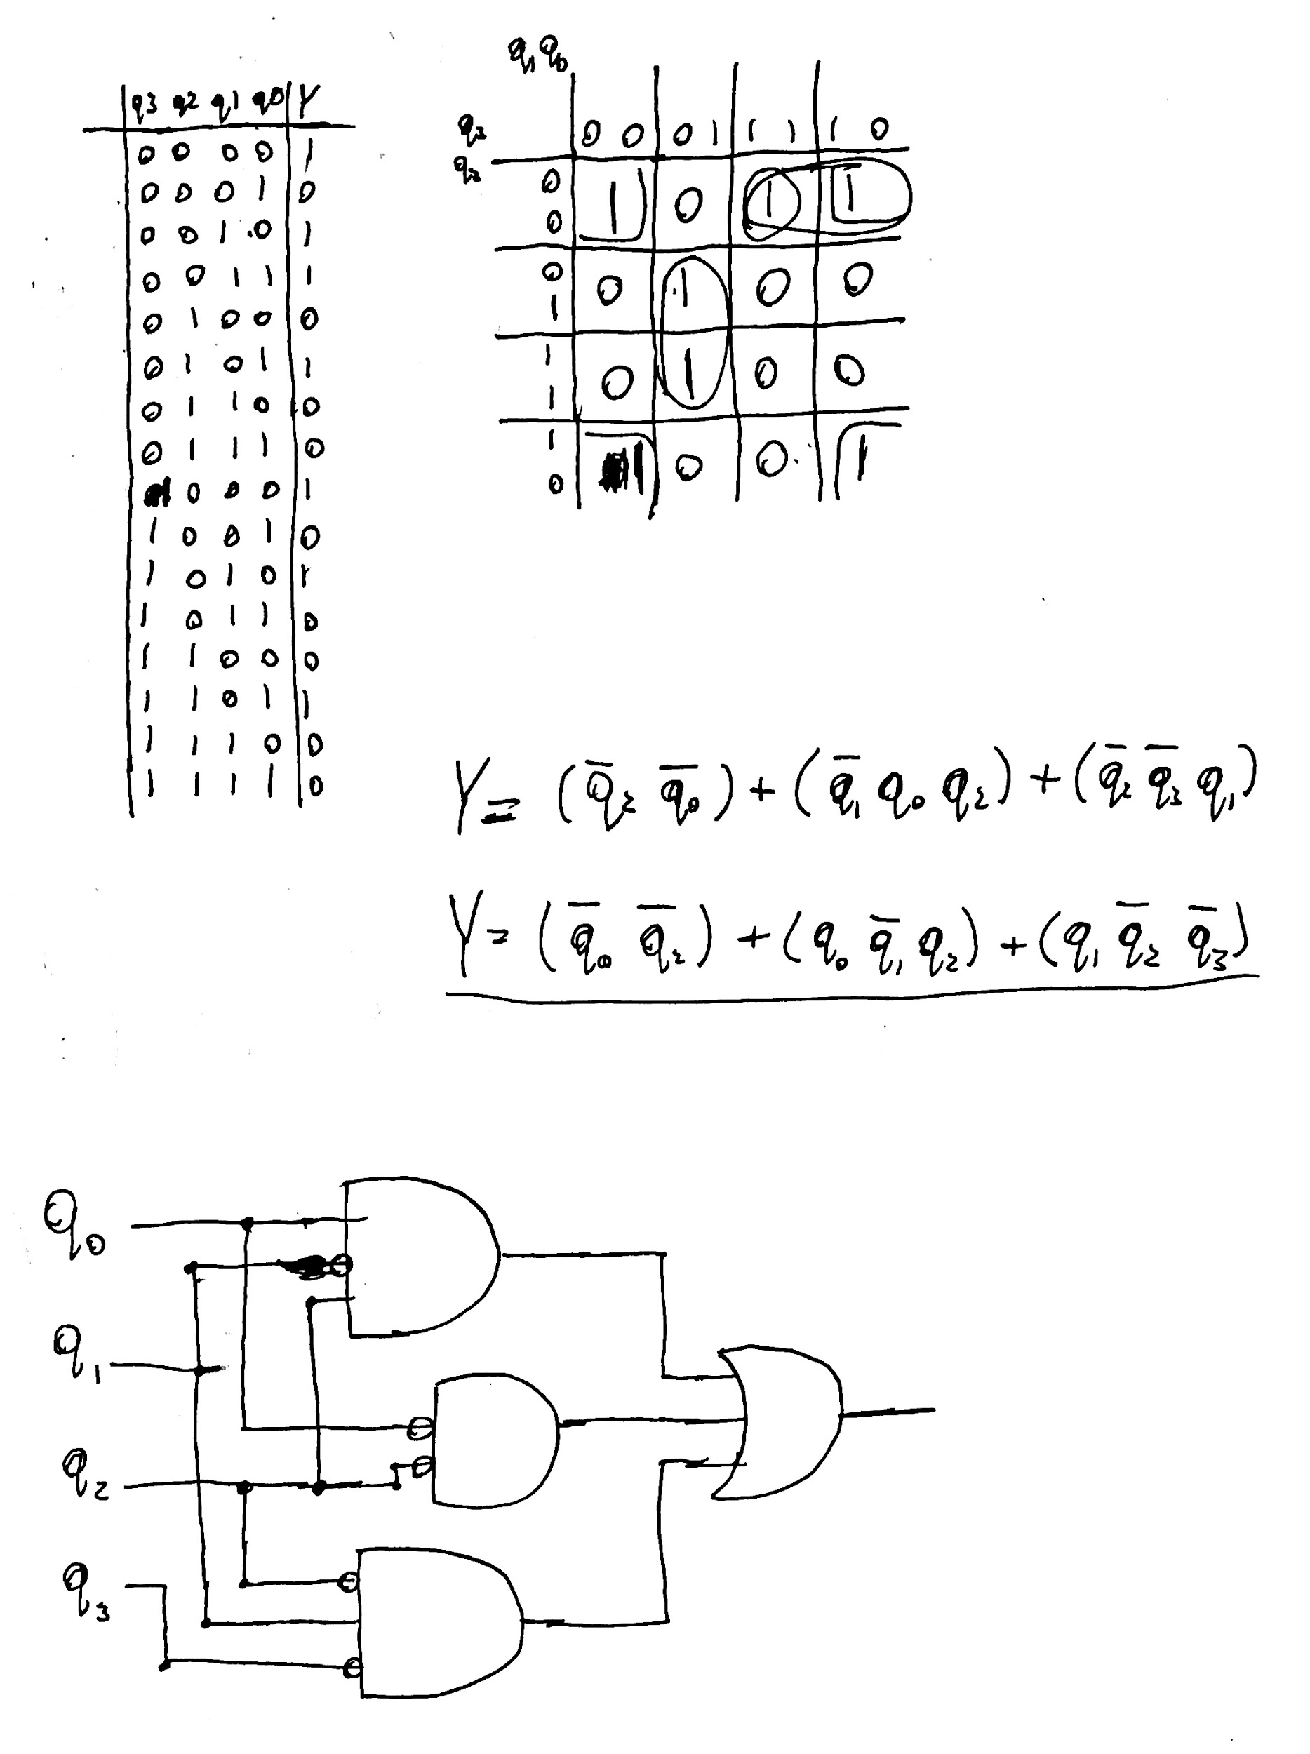

# 

# 

# 

# 

# 

# 

# 

# 

Logisim Simulation of Module:

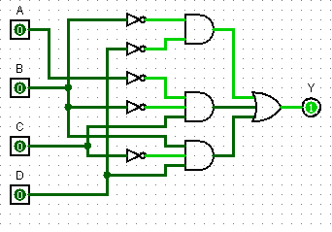

Actual Module:

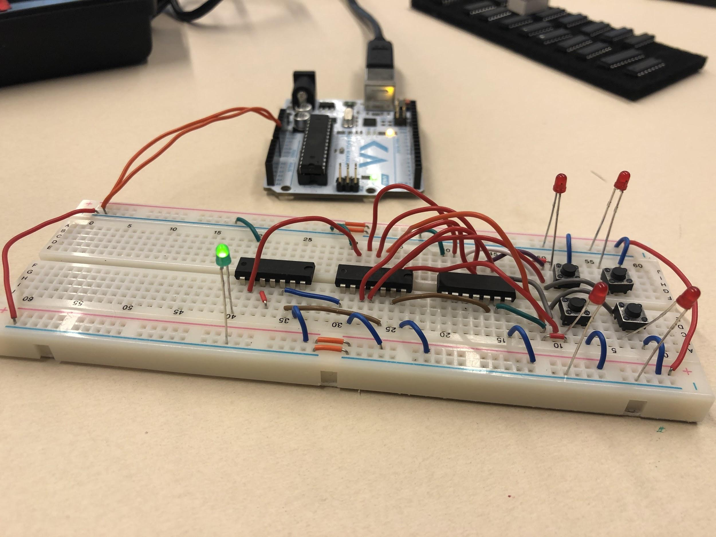

# 

# Module 3

### Goal

The goal of this module was, given an FSM model, to build the very same FSM in my breadboard.

### Procedure

This module’s goal was achieved by initially finding the truth table for this FSM, separating it into the truth tables of the two distinct outputs, and finally by using K-Maps to, similarly to module 2, design a combinational logic circuit for this FSM. A D-Flip Flop was used as a state register, so as to keep the circuit synchronous.

While many classmates chose to use MUXes, as the crazy person that I am, I decided to build the circuit out of logic gates only. It became *messy* to say the least, but worked!

### Showcase

Module Diagram (truth table, k-maps, boolean equations):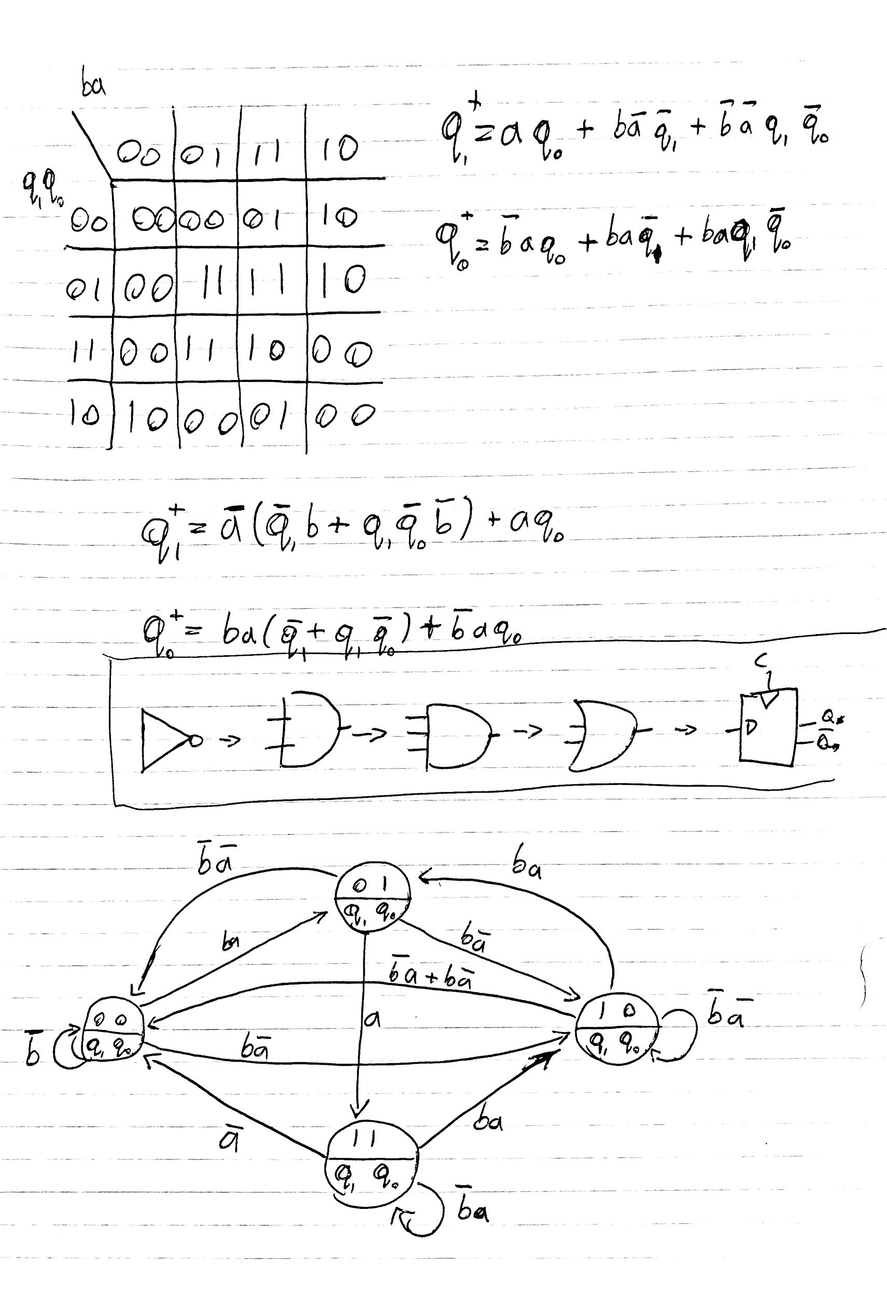

### 

Logisim Simulation:

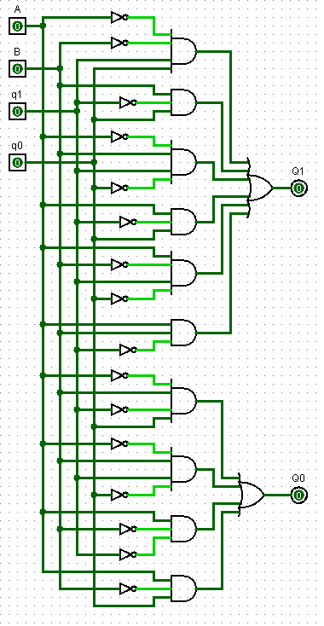

Actual Module:

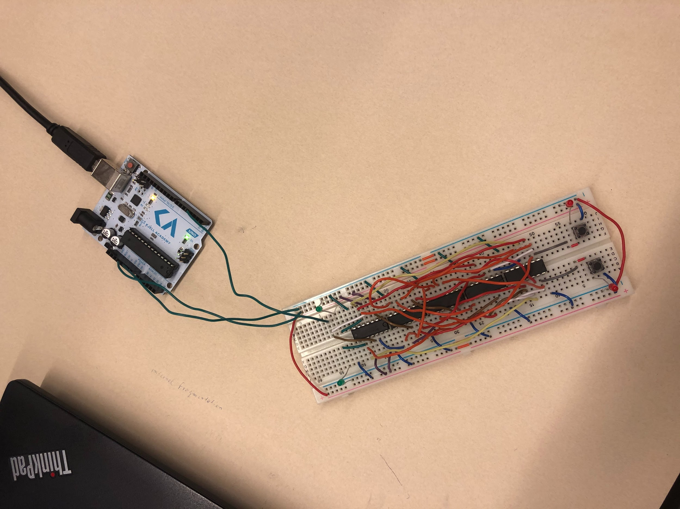

# Module 4

### Goal

The goal of this module was to, using diode ROM, cycle through the digits of my birthday using the 7-segment LED display provided in the lab kit.

### Procedure

In order to reach this goal, I had to use a 3-bit binary decoder along with the Arduino clock, to cycle through 8 distinct states (as shown by which LED is turned off below). Then, using resistors and diodes as a sort of “AND” gate, I will hard-wire a memory based on 4-bits that will be fed into the 7-segment display decoder, in order to display each digit of my birthday, one at a time.

Since my birthday is May 13th, 2002, the expected digits are 2-0-0-2-0-5-1-3.

### Showcase

ROM Memory Diagram: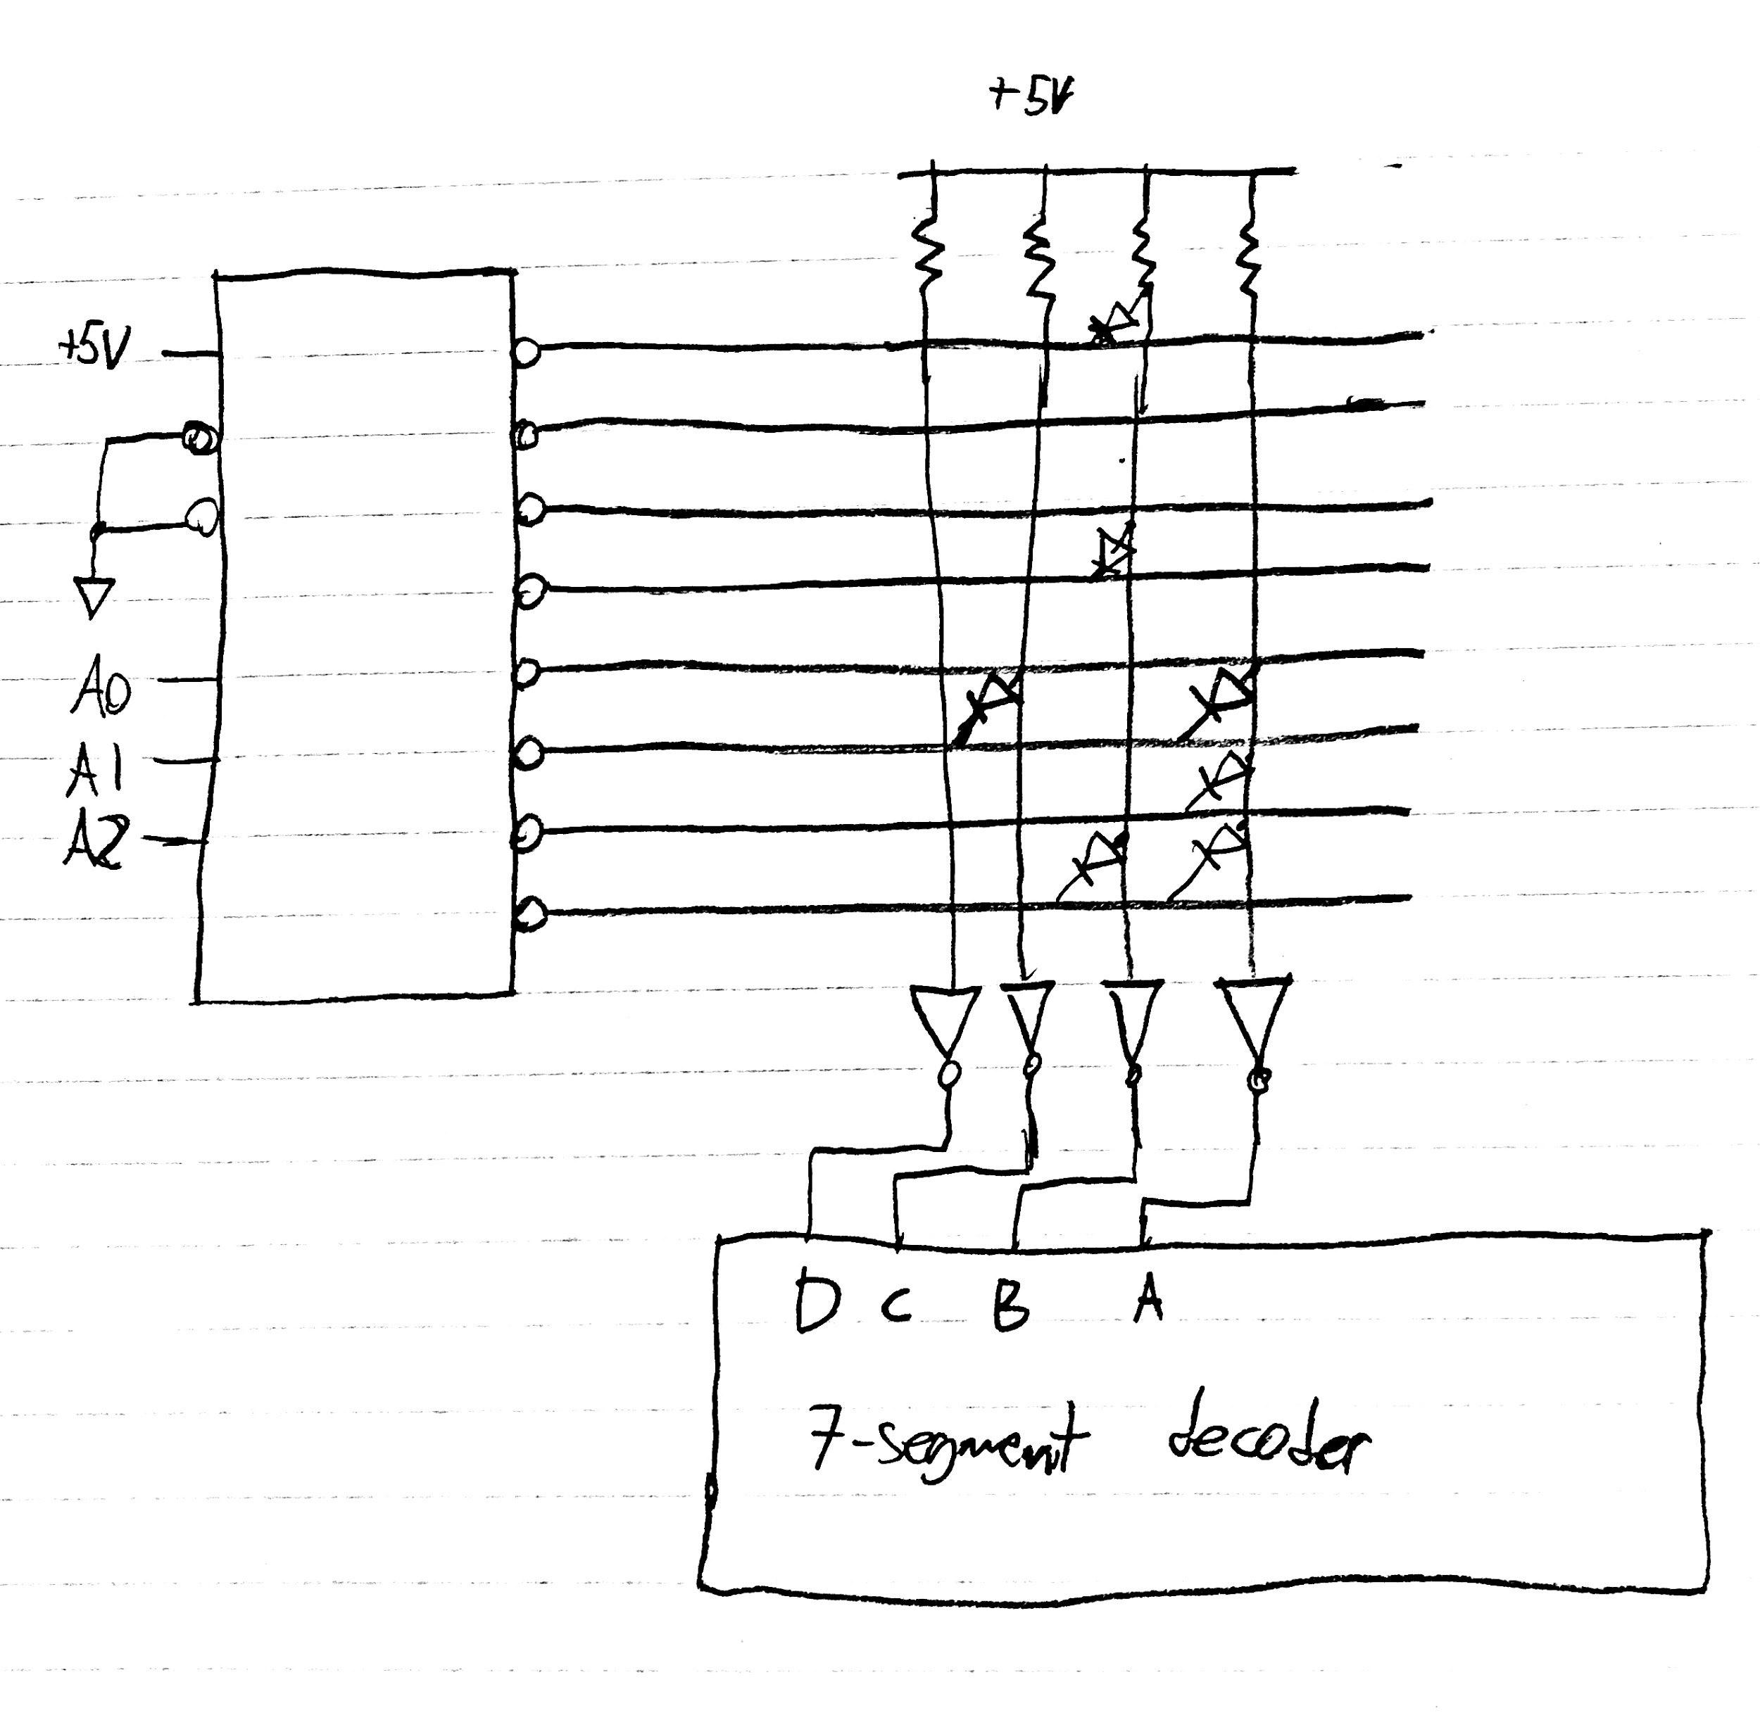

Actual Module: